Title: Deep Learning
Publication venue/year: doi:10.1038/nature14539 (2015)
Why am I reading this paper (optional): To gain knowledge about deep learning and how it is evolved until become popular over traditional ML techniques. The different training ways required for parallelization.
Summary: The paper discuss conventional ML techniques and the main challenges related to it. It also introduce the concept of DL and how it solves many problems such as automatic feature engineering. DL models need an immense amount of resources and time to be trained well. The usage of GPUs instead of CPUs allowed researchers to train 10x or 20x fastest. DL has two advantages over conventional ML method. First, it can learn distributed representations (instead of N-grams) which enable generalization to new combinations of the values of learned features beyond those seen during training. Second, composing layers of representation in a deep net brings the potential for another exponential advantage. RNN could be used for machine translation but it suffers from problem such as vanishing gradient or exploding gradient. LSTM could be used with RNN to help to store information for a very long time.

Research Problem Addressed:
- Conventional machine-learning techniques were limited in their ability to process natural data in their raw form as it requires domain expertise to design feature extractor that transform the raw data into a suitable internal representation.
- Conventional ML requires a considerable amount of engineering skill and domain expertise to hand design good feature extractor (select important features required for discrimination).

Proposed solution:
- They propose to use Deep Learning methods with multiple level of representation. Representation learning is a set of methods that allows a machine to be fed with raw data and to automatically discover the representations needed for detection or classification.
- Good Features are learned automatically using deep learning.
- DL with many nonlinear layers can implement intricate function of its inputs.
- Use Backpropagation to train multilayer architectures by simple stochastic gradient descent (help to have parallelization, scale up).
- Use of ReLU make the network learn faster specially in the network with many layers.
- Use GPU which allow us to train network faster (10x or 20x).
- Convolution NN is easily trained and can much better than networks with full connectivity between adjacent layers, it had been applied with great success to the detection, segmentation and recognition of objects and regions in images.
- Use recurrent NN (RNN) when the inputs are sequential. RNN use a state vector which contains information about the history of all past sequences of input. RNN training is a problematic problem because the propagated gradients either grow or shrink at each time step (explode or vanish).
- Use of deep RNN as encoder, converts image pixels into activity vector, and use of RNN, similar to those used in machine translation, as decoder to be able to translate images into English sentences.
- The disability of RNN to store information for a long time lead to the arising of the long short term memory (LSTM) networks. It helps to remember input for a long time using a special unit called memory cell which acts like an accumulator.
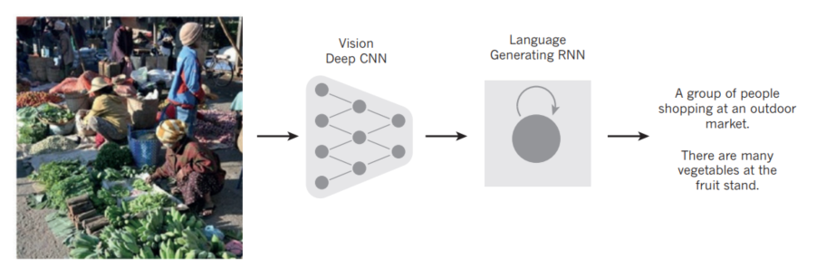

Your comments: In this paper, they discussed conventional ML methods stressing in its main drawbacks. They introduce DL and how can be used to train immense model with hundreds of layers using GPU. I think these DL techniques required to run in a distributed manner because of the limitation of the hardware capability

Strong points:

Weak points:

Next steps:
- In human vision, we can combine convolution nets with RNNs which use reinforcement learning to decide where to look
- Combining representation learning with complex reasoning in fields such as AI may lead to great progress.

